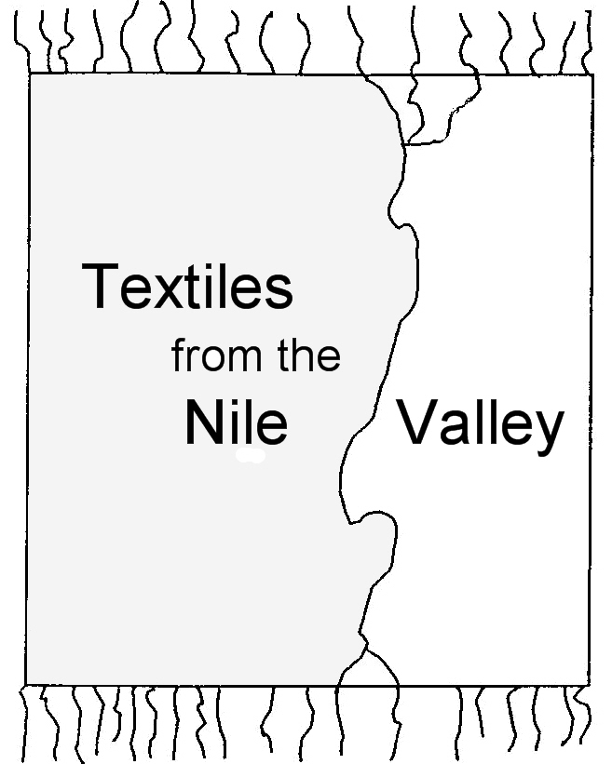 | REMINDER  07-08-2009  Prof. Dr. Antoine De Moor  Windekekouter 90  B-9860 Scheldewindeke  antoine.demoor@UGent.be  Dr. Caecilia Fluck  Suederweg 13  D-25923 Suederluegum  CaeFluck@tele2.de

Dear Colleagues,

As announced in the previous circular letters the next conference of the “Textiles from the Nile Valley” research group on “Accessories” will take place from Friday 2nd to Saturday 3rd October 2009 at HeadquARTers, Van Aerdtstraat 33, B-2060 Antwerp.
A reception (incl. snack) will be offered by our host on Thursday 1st October, 18.30 h at the same location to which all of you are most welcome. On this occasion Lannoo-publishers will present the proceedings of our last conference.

All speakers who did not confirm yet are kindly requested to give us the final title of their contribution and if possible to send us an abstract by the end of this month (31st August).
We kindly ask those who would like to participate without giving a paper and did not register yet to confirm their participation by the end of August, too.
In case you subscribed for the conference but realised that you cannot come, please, let us know as quickly as possible.

If you like, please send us your individual bibliography (2007-2009) until 10th September 2009. We shall compile it for all participants then. These lists have always been well appreciated. There will be a book-table during the conference where participants can lay out information or show recent publications on textile research.

If you still need a hotel and want to book one of the hotels listed at the end of this letter for a reduced price during your stay at Antwerp, we urgently advice you to contact Heidi Scheers from Katoen Natie as soon as possible [Travel@katoennatie.com, mail: Heidi Scheers, Van Aerdtstraat 33, B-2060 Antwerp, phone: 0032-32-2216823 (Heidi Scheers) or 0032-3-2216825 (Sofie Mangelschots). If you prefer to stay elsewhere, please arrange your own booking.

There will be no official programme on Friday evening. For all those who prefer to stay with the group we are going to reserve some tables at a central restaurant. A menu will be offered on your own costs [25 Euro + 13 Euro for drinks (white wine and red wine, water, coffee]. For a better planning, please tell us, if you already know that you will dine with the group.

The “Textiles from the Nile Valley”-conference will be followed by a meeting of study group “Gender and age” of the European project “Clothing and Identities in the Roman World (DressID, further information: www.dressid.eu)”. It will take place on Saturday 3rd October, afternoon. Members of the DressID-project will report on the progress of their individual studies. All participants of the “Textiles from the Nile Valley” conference are invited to join. The meeting of study group “Rome and the provinces”, announced for Sunday 4th October is cancelled.

You will get a further circular with the final program of the “Textiles from the Nile Valley” conference and the meeting of the study group “Gender and Age” by midst September.

For any further questions do not hesitate to contact one of the undersigned.

We are looking forward to meet you in Antwerp and wish you a pleasant stay.

Sincerely, Yours

Antoine de Moor
Caecilia Fluck

Choice of hotels in Antwerp
• Express by Holiday Inn (close to Katoen Natie) 80 € per night/room, incl. breakfast

• Radisson Sas Park Lane Hotel (near main station) 144 € per night/deluxe single room; 161 € per night/deluxe double room; grab and run breakfast incl., breakfast buffet c. 25 €

• Theater Hotel (centre) 82 € per night/single room; 102 € per night/double room; breakfast not included

